1. Opening the terminal and listening to the port 8888. Used command “man ipconfig” to check the main option descriptions. Found current date and time, when the system rebooted, system information, and whether a network interface is running in a promiscuous mode.

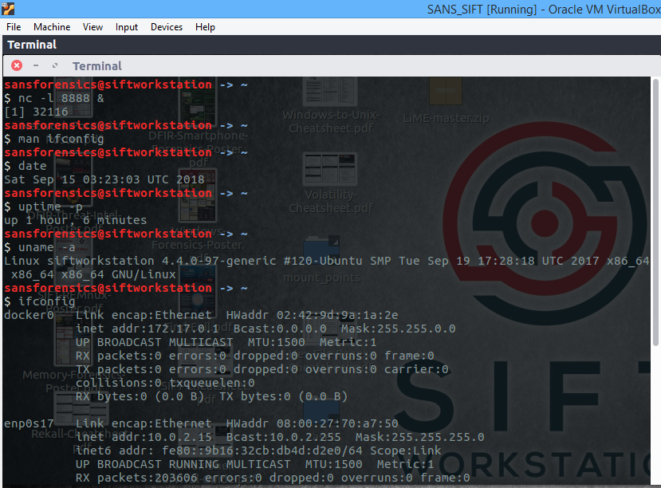

2. usual and suspicious processes and services

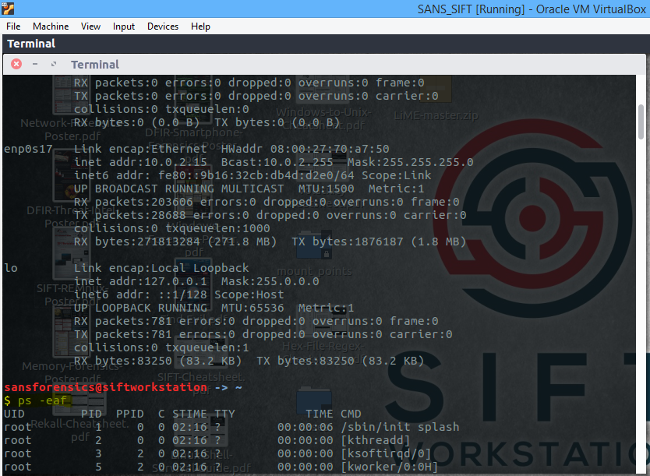

3. Open in memory, files opened by the process PID

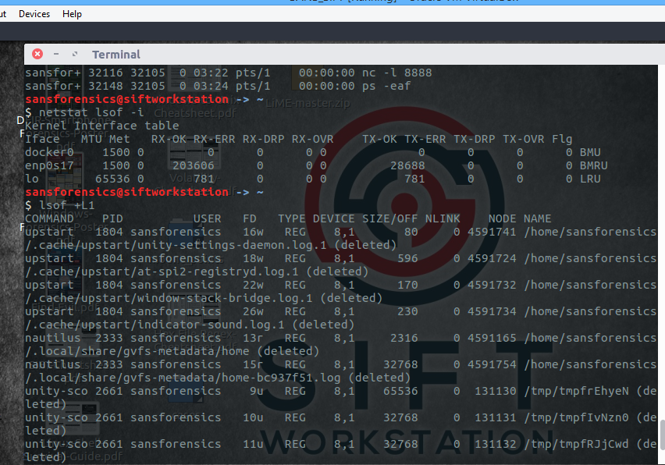

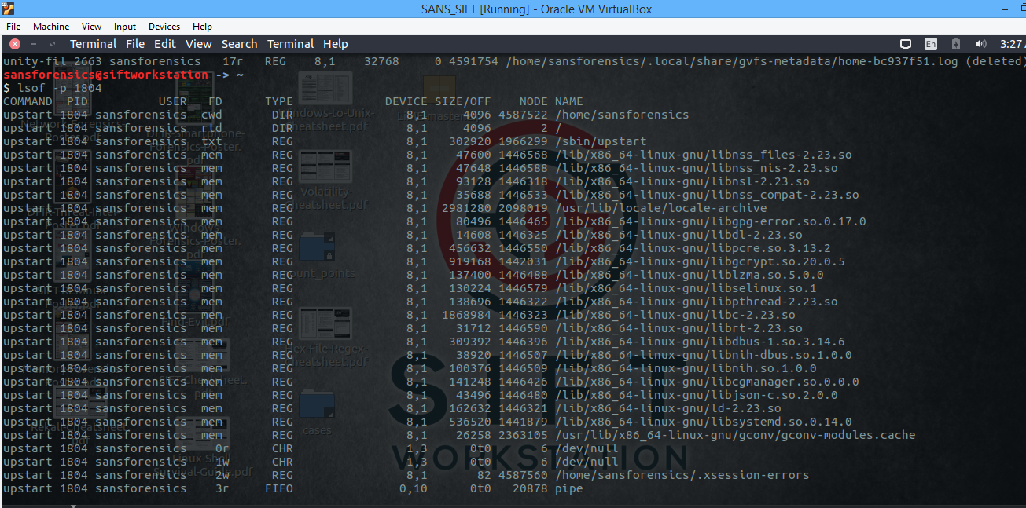

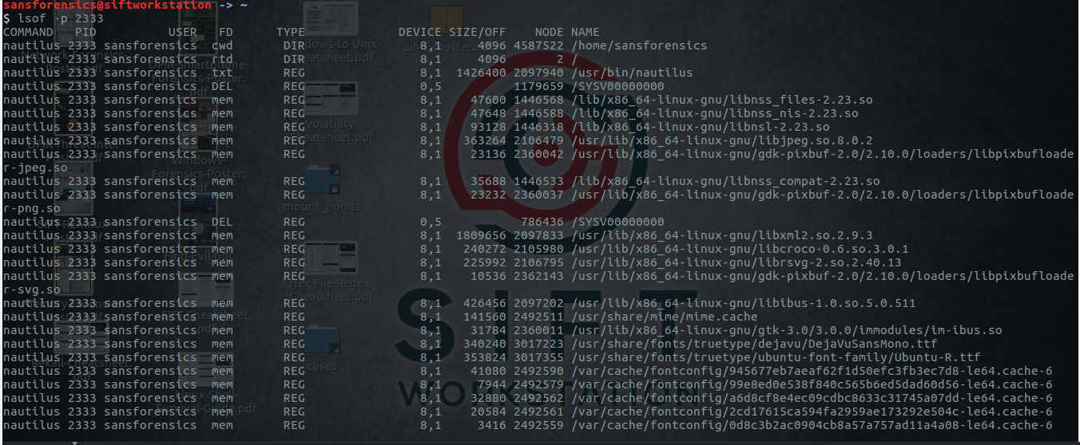

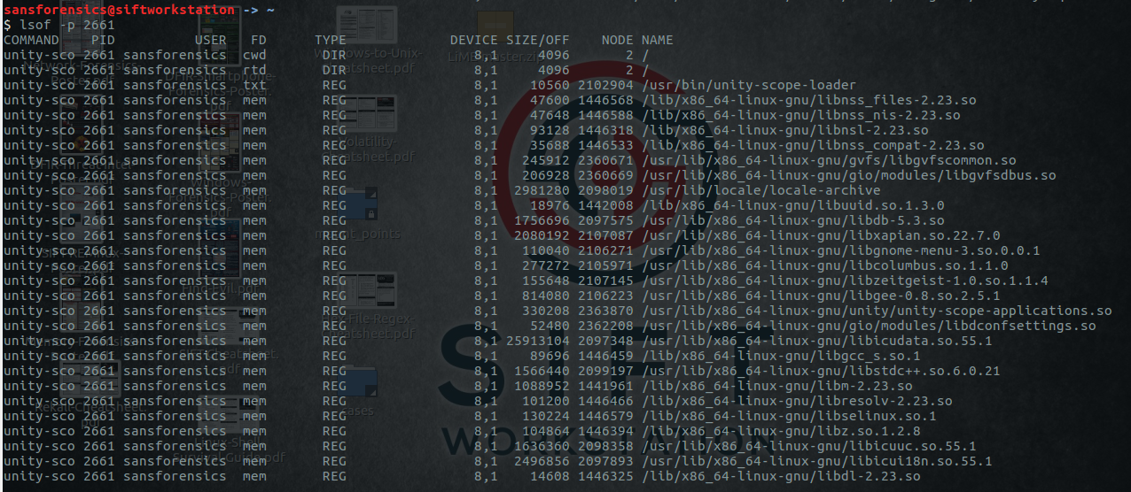

5. Finding the currently logged in users

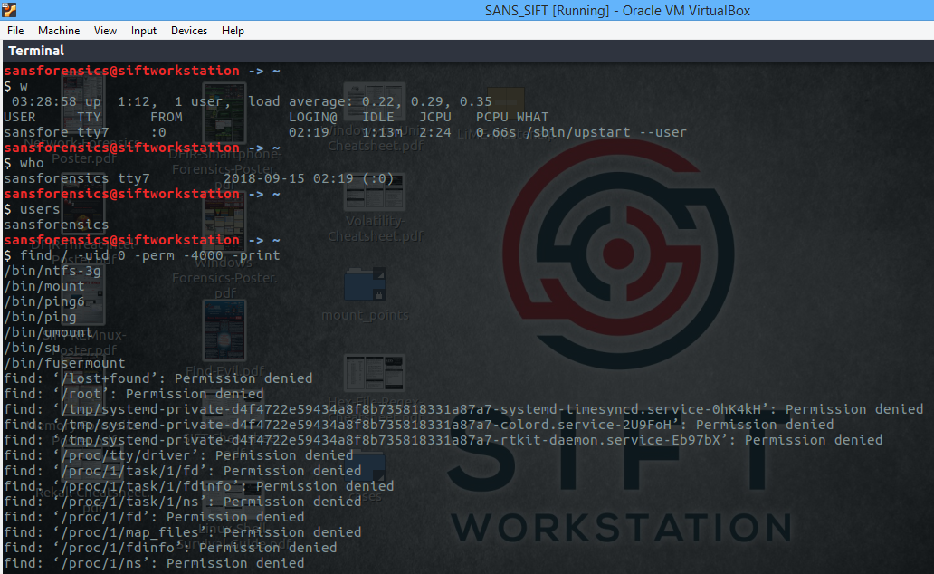

6. all root owned SUID files

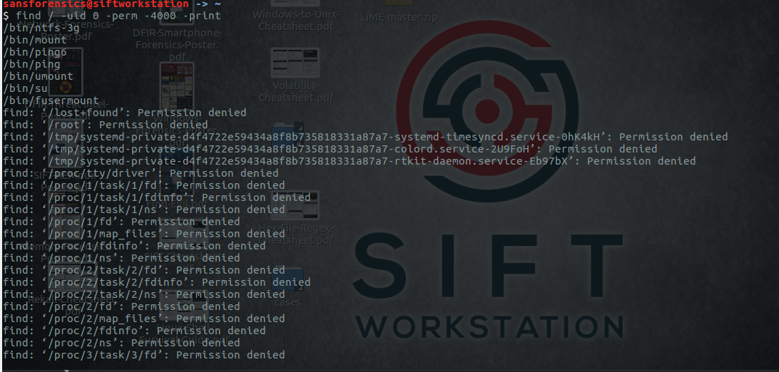

7.find a list of previous users, free disk space, and amount of free and used physical and swap memory in system

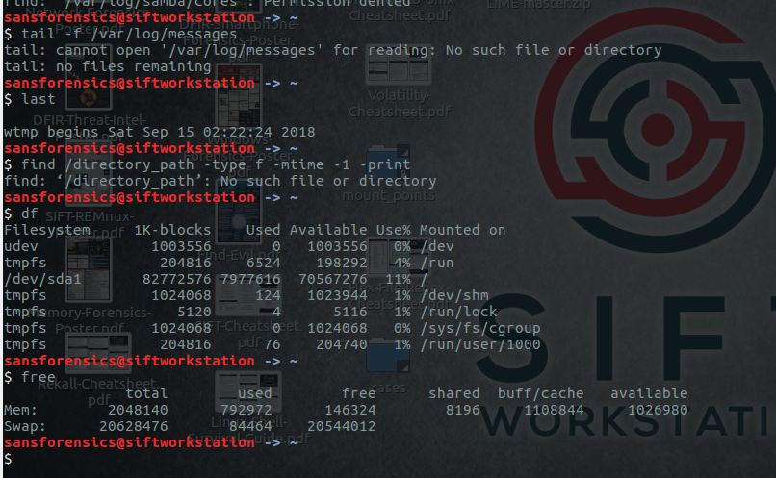

8.

